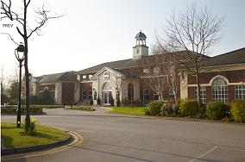

Local Primary Mental Health Support Services – the way forward
A Practice Sharing Day
to support the
Implementation of services under
Part 1 of the Mental Health (Wales) Measure 2010
St David’s Park, Ewloe, Flintshire
24th April 2012

Registration Form
Your Details:
Title:
First Name:
Surname:
Job Title:
Organisation:
Address:

Telephone:
Email address:
Any special dietary
requirements:
Any special access
requirements:

Data Protection Statement:

Any personal data that you submit will be held and processed in accordance with the Data Protection Act. The Wales Mental Health in Primary Care Network (WaMH in PC) will hold this information in order to send you further information about this event and the information may be viewed by authorised members of WaMH in PC. WaMH in PC would like to include your name, job title and organisation in a delegate pack which will be distributed to all attendees on the day.

Please tick here if you are NOT content for WaMH in PC to do so.

I am not content

If you would NOT like WaMH in PC to hold your contact details for the purposes of sending you further information relating to the Wales Mental Health in Primary Care Network, conferences and events please tick here.

I would not like my details retained

Print Name ……………………………………………………………….

Signed …………………………………………………………………….

Registration forms to be returned

via email to: lhills@rcgp.org.uk

or

by post to: Lesley Hills (RCGP Wales),
Project Manager WaMH in PC, Regus House, Falcon Drive, Cardiff Bay, Cardiff CF10 4RU

